# Code Regression and Resulting Model

|  |
| --- |
| #Load the data set  column_name <- c("crim","zn","indus","chas","nox","rm","age","dis","rad","tax","ptratio","b","lstat","medv")  housing <- read.table("HW6/data/housing.data",col.names=column_name)  #Fit the Linear Data Model  fit <- lm (medv~crim+zn+indus+chas+nox+rm+age+dis+rad+tax+ptratio+b+lstat,data=housing)  plot(fit)  summary(fit) |

|  |
| --- |
| > **summary(fit)**  Call:  lm(formula = medv ~ crim + zn + indus + chas + nox + rm + age +  dis + rad + tax + ptratio + b + lstat, data = housing)  Residuals:  Min 1Q Median 3Q Max  -15.595 -2.730 -0.518 1.777 26.199  Coefficients:  Estimate Std. Error t value Pr(>|t|)  (Intercept) 3.646e+01 5.103e+00 7.144 3.28e-12 ***  crim -1.080e-01 3.286e-02 -3.287 0.001087 **  zn 4.642e-02 1.373e-02 3.382 0.000778 ***  indus 2.056e-02 6.150e-02 0.334 0.738288  chas 2.687e+00 8.616e-01 3.118 0.001925 **  nox -1.777e+01 3.820e+00 -4.651 4.25e-06 ***  rm 3.810e+00 4.179e-01 9.116 < 2e-16 ***  age 6.922e-04 1.321e-02 0.052 0.958229  dis -1.476e+00 1.995e-01 -7.398 6.01e-13 ***  rad 3.060e-01 6.635e-02 4.613 5.07e-06 ***  tax -1.233e-02 3.760e-03 -3.280 0.001112 **  ptratio -9.527e-01 1.308e-01 -7.283 1.31e-12 ***  b 9.312e-03 2.686e-03 3.467 0.000573 ***  lstat -5.248e-01 5.072e-02 -10.347 < 2e-16 ***  ---  Signif. codes: 0 '***' 0.001 '**' 0.01 '*' 0.05 '.' 0.1 ' ' 1  Residual standard error: 4.745 on 492 degrees of freedom  Multiple R-squared: 0.7406, Adjusted R-squared: 0.7338  F-statistic: 108.1 on 13 and 492 DF, p-value: < 2.2e-16 |

# Diagnostic Plot & Outlier

|  |  |  |  |  |  |  |
| --- | --- | --- | --- | --- | --- | --- |
| **Residuals**  **Thresholds:** Standard Residuals  (-3 and 3) | |  |  | | --- | --- | |  |  | |  |  | | Outlier Index:[187,365,369, 370,371,372,373,413]  **Reason:** Clearly the residuals plot doesn’t seems to be linear and there is a clear pattern of non-linearity (red line). The residuals values seems to be dependent on the fitted values, as for the initial “fitted values” (before 10) and later (after 30), there are few observations where the “true value” is far above the prediction line, which cause the residuals to high (**standard** **residuals** > 3 standard deviation), except for the one point (index = 365), where the “true value” is far below the prediction line and cause the residuals to be high on negative (-ve) side(below < -3 standard deviation from mean). Also the prediction between 20 & 30, there are around 3 point (index = 369, 372 and 373) which is far above the prediction line and cause high residuals (above >3 standard deviation). If we look into the histogram, it also observed that most of the fitted data lies within the standard residuals between -3 & 3. So, these points (187,365,369, 370,371,372,373,413) may have an influence on the regression line and needs for review as an outlier to verify the impact on the parameters estimates. |
| **Cooks Distance**  **Thresholds:** > 0.04 | |  |  | | --- | --- | |  |  | | Outlier Index:[215,365,366,368,369, 370,371,372,373,413]  **Reason:** There are few observations where the cook’s distance seems to be higher than the other observations with the setting threshold = 0.04. Also from the histogram, it observed that most of the data point lies within 0.04 of cook’s distance . Since the presence of these points has an influence on the regression line (high cook’s distance), where the other points are poor at predicting as compared to the point prediction of leaving that point out of the regression, these observations/points (215,365,366,368,369, 370,371,372,373,413) needs to review as an outlier to verify the impact on the parameters estimates |
| **Leverage**  **Thresholds:** Standard Residuals  (-3 and 3) | |  |  | | --- | --- | |  |  | | Outlier Index:[365,369,372,373]  **Reason:** Though the leverage isn’t high for any of the data points (also visible from the histogram, most of the “hat values” are under 0.10), the standardize residuals seems high (over 3 standard deviation from the mean) for few of the observation, where the index (365,369,372,373) are the already identified from the standardized residual plots from the 1st row. Also There are no observation which shows gigantic cook’s distance (over 0.5) and the lower section we not even seen the cook’s distance for 1. |

# New Diagnostic Plot

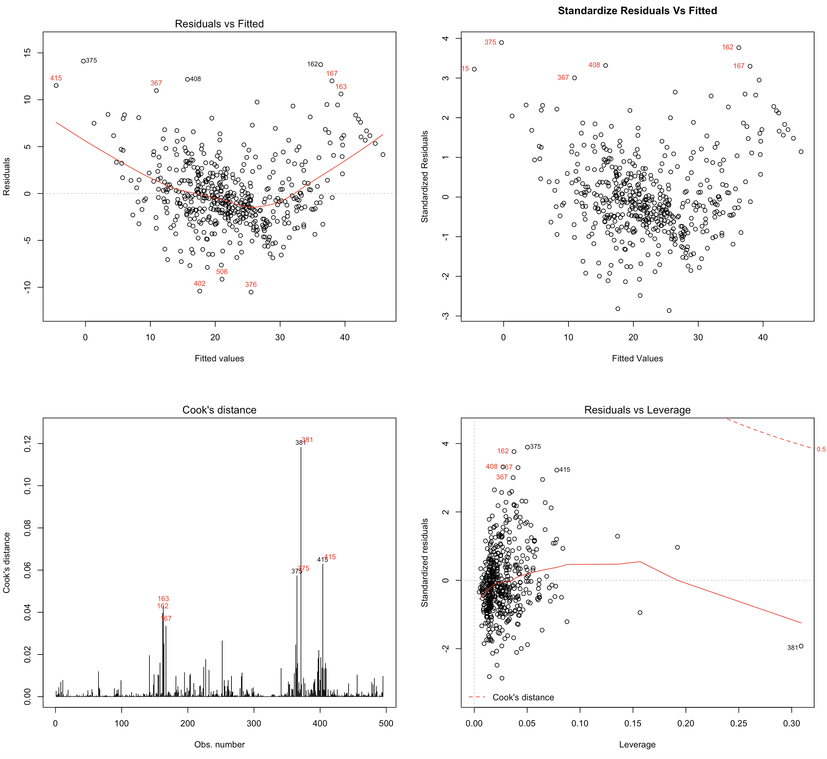

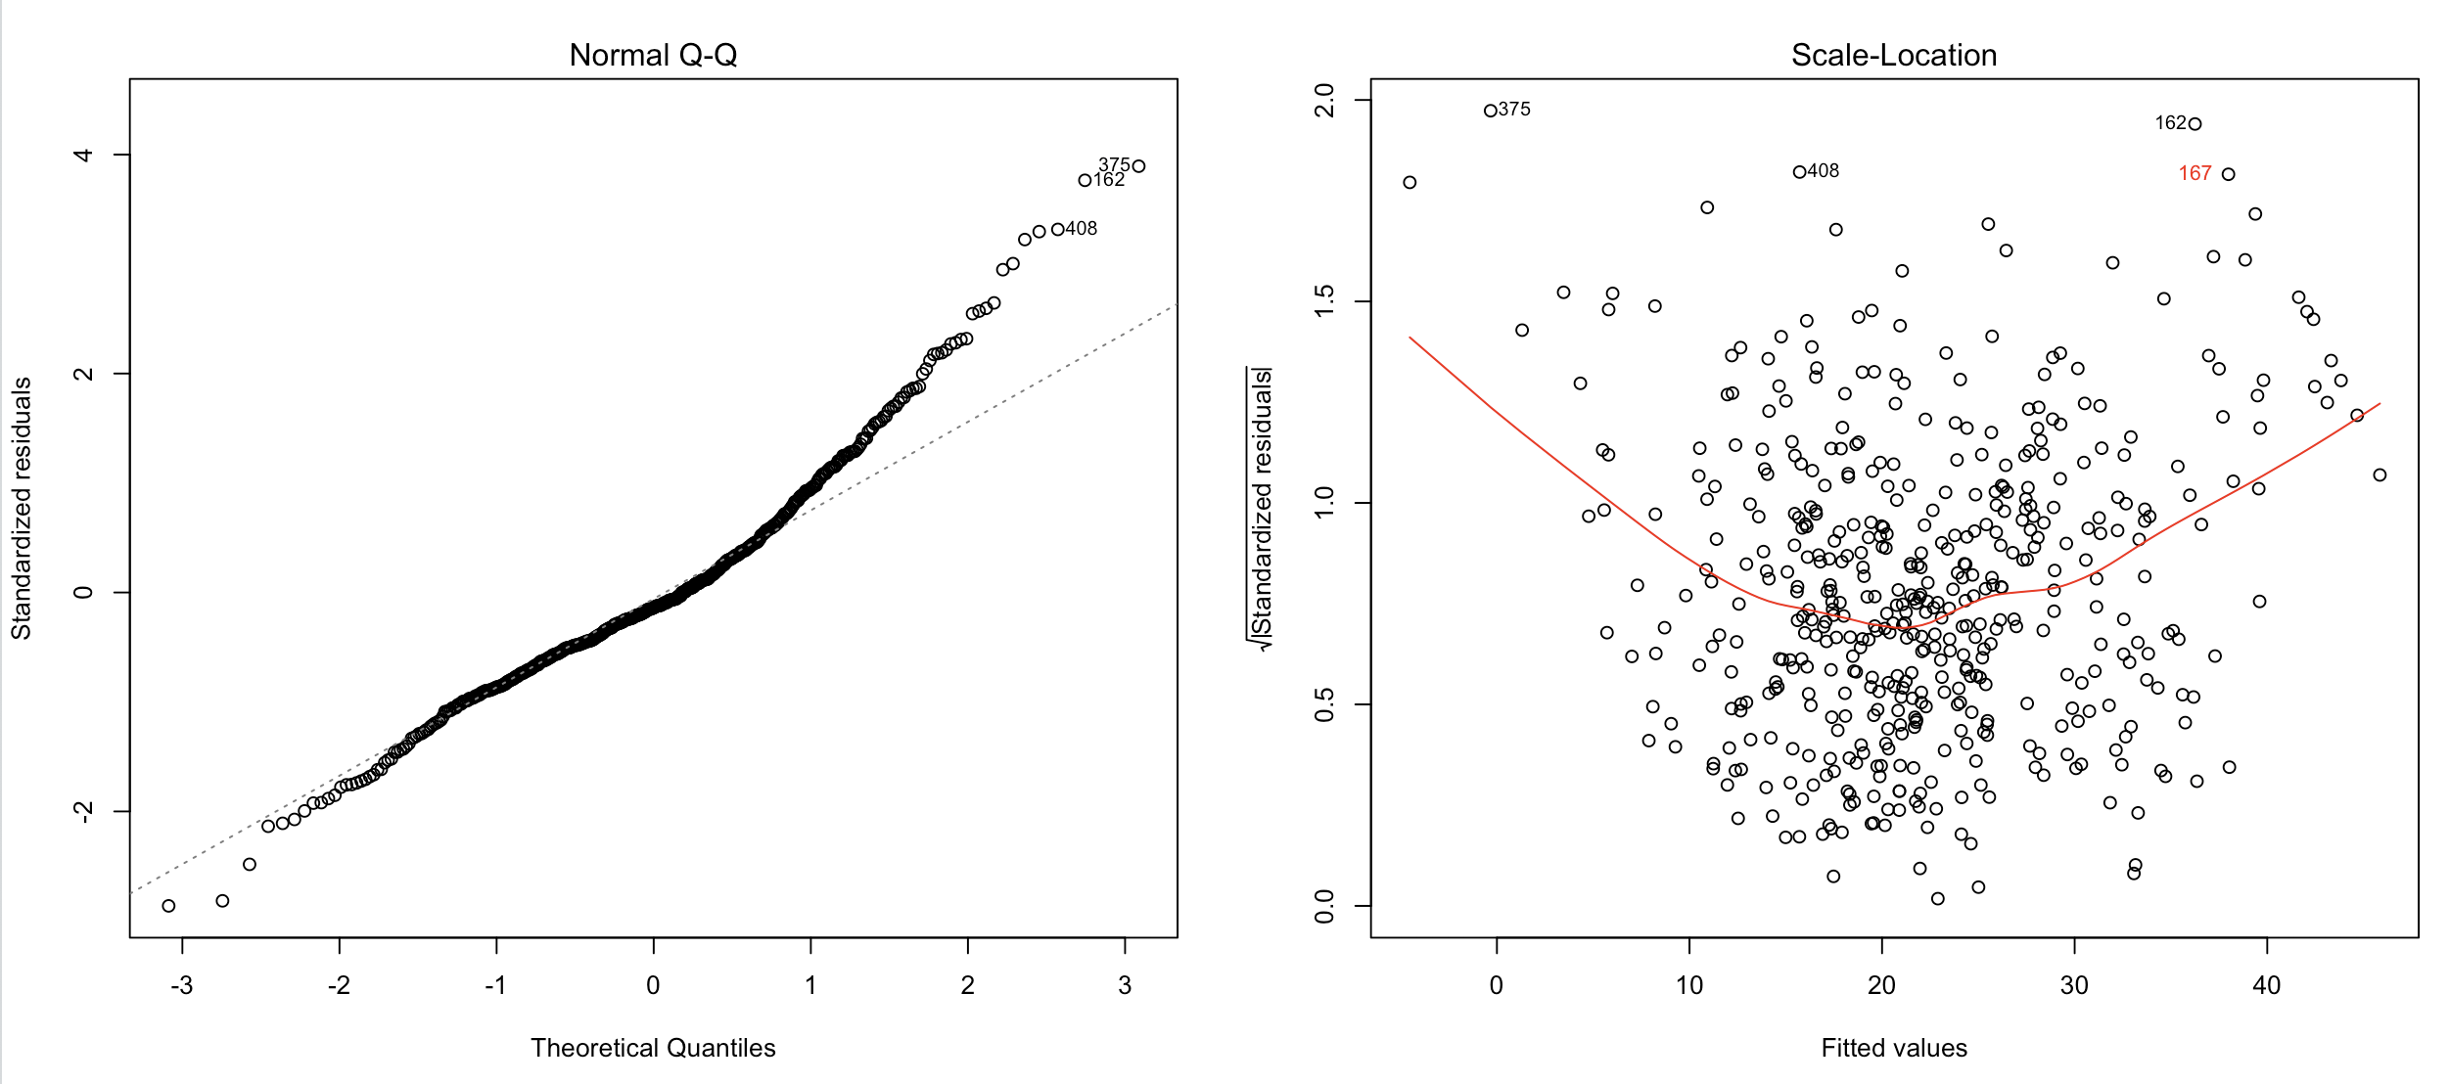

# Code – SubProblem 2

|  |
| --- |
| #########################################################################################################  #  # Residuals, Cooks Distance, Leverage ######## After Outlier being removed  #  #########################################################################################################  #-------------------------------------------Diagnostic Plot (Plot 1,3) #### Residuals  point_exclude <- c(187,215,365,366,368,369,370,371,372,373,413)  housing_remove <- housing[-(point_exclude),]  par(mfrow=c(2,2))  #rownames(housing_remove) = 1:nrow(housing_remove) #reset the rownames  fit_after <- lm (medv~crim+zn+indus+chas+nox+rm+age+dis+rad+tax+ptratio+b+lstat,data=housing_remove)  res_after <- fit_after$residuals  plot(fit_after,which=1)  text(predict(fit_after),res_after,ifelse( ((rownames(housing_remove)==375 | rownames(housing_remove)==162 | rownames(housing_remove)==408)  | (!(res_after < -9 | res_after > 10)) ),"",rownames(housing_remove) ),  cex= 0.8,pos=3,col='red')  #hist(res_after)  rstandards_after = rstandard(fit_after)  plot(predict(fit_after),rstandards_after,xlab="Fitted Values",ylab="Standardized Residuals",main="Standardize Residuals Vs Fitted")  text(predict(fit_after),rstandard(fit_after),ifelse((!(rstandards_after < -3 | rstandards_after > 3)),"",rownames(housing_remove) ),  cex= 0.8,pos=2,col='red')  #hist(rstandards_after)  #-------------------------------------------Diagnostic Plot (Plot 4,5) #### Cook’s Distance, Leverage  #par(mfrow=c(2,2))  plot(fit_after,which=4)  text(rownames(housing_remove),cooks.distance(fit_after),ifelse( ((rownames(housing_remove)==366 | rownames(housing_remove)==372 | rownames(housing_remove)==405)  | (cooks.distance(fit_after) < 0.03) ),"",rownames(housing_remove) ),  cex= 0.8,pos=3,col='red')  #hist(cooks.distance(fit_after))  plot(fit_after,which=5)  text(hatvalues(fit_after),(rstandard(fit_after)),ifelse( ((rownames(housing_remove)==375 | rownames(housing_remove)==415)  | (!(rstandard(fit_after) < -3 | rstandard(fit_after) > 3)) ),"",rownames(housing_remove) ),  cex= 0.8,pos=2,col='red')  #hist(hatvalues(fit_after))  par(mfrow=c(2,2))  plot(fit_after,which=2)  plot(fit_after,which=3)  text(predict(fit_after),sqrt(rstandard(fit_after)),ifelse( ((rownames(housing_remove)==375 | rownames(housing_remove)==408 | rownames(housing_remove)==162)  | (!(sqrt(rstandard(fit_after)) < -1.8 | sqrt(rstandard(fit_after)) > 1.8)) ),"",rownames(housing_remove) ),  cex= 0.8,pos=2,col='red') |

# Box Cox Transformation

Best Value of Lambda = 0.2727273

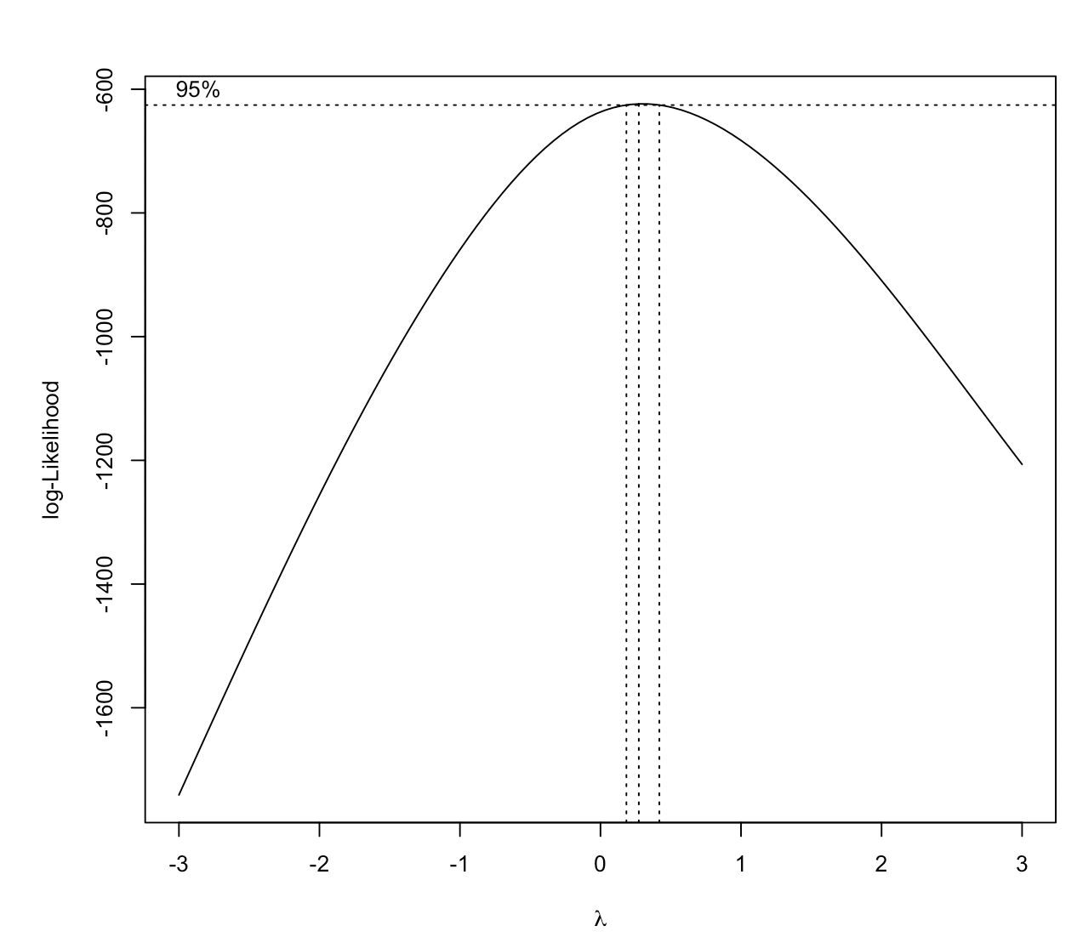

# Plot Standardize Residuals Vs Fitted Price

|  |  |
| --- | --- |
| **Plot** - Standardize Residuals Vs Fitted Values |  |
| **Plot** – True Value against Predicted value (After Box Cox Transformation) |  |

# Code – Sub Problem3 & 4

|  |
| --- |
| #########################################################################################################  #  # Box Cox Transformation (After Removing Outlier)  #  #########################################################################################################  library(MASS)  bc = boxcox(fit_after,lambda = seq(-3,3))  best_lam=bc$x[which((bc$y == max(bc$y)))]  fit_modified_after_boxcox <- lm((((medv^best_lam)-1)/best_lam)~crim+zn+indus+chas+nox+rm+age+dis+rad+tax+ptratio+b+lstat,data=housing_remove)  par(mfrow=c(2,2))  plot(fit_modified_after_boxcox)  #########################################################################################################  #  # Plotting the Data (Original Vs Precited)  #  #########################################################################################################  par(mfrow=c(2,2))  xlim=c(0,50)  ylim=c(-4,4)  plot ((1+(predict(fit_modified_after_boxcox))*best_lam)^(1/best_lam),rstandard(fit_modified_after_boxcox),xlab="Fitted Values",ylab="Standardized Residuals",main="Standardize Residuals Vs Fitted",xlim=xlim,ylim=ylim)  y_pred <- (1+(predict(fit_modified_after_boxcox)*best_lam))^(1/best_lam)  plot(housing_remove$medv,y_pred,xlab = "y_true (Original)",ylab="y_pred(Prediction)",main = "Modified Data (After Removing Outlier) - Box Cox (Reverse)") |